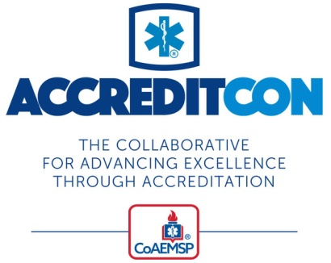
Date
Dear [MANAGER’S NAME],
I would like to attend ACCREDITCON, a collaborative hosted by the CoAEMSP to be held in Oklahoma City, Okla. from May 29-June 2, 2024.
ACCREDITCON is designed to be a comprehensive event offering every resource needed for successfully working through the CAAHEP accreditation process. The sessions, tools, and resources that will be available at ACCREDITCON can help me be even more successful in my role, which will ultimately benefit our program as well.
ACCREDITCON is unique in offering intensive learning sessions geared solely to gaining and maintaining accreditation success. It builds on CoAEMSP’s highly popular accreditation workshops by expanding on the content and resources delivered at those workshops. While attending, I will be able to immerse myself in those how-to sessions, find answers to specific questions, and learn from others. As a result, ACCREDITCON will allow our program to:
- avoid costly and time-consuming mistakes in the accreditation process
- make our site visit more efficient
- benefit from valuable ideas and tips from leaders, colleagues, and mentors
- work smarter not harder
- learn ways to improve our performance as leaders in the accreditation process
From the information I have obtained from the ACCREDITCON website (www.accreditcon.org), I am confident that my attendance will have a direct and positive impact on the quality of our program and my work as [OFFICIAL TITLE] for [NAME OF PROGRAM/ORGANIZATION]. Upon returning from ACCREDITCON, I look forward to sharing what I learned, and building an action plan for implementation.
I have broken down the approximate cost of my attendance at ACCREDITCON:
- Airfare/Travel: [$ AMOUNT]
- Hotel: $/Night [$ AMOUNT]
- Meals: $/Day [$ AMOUNT]
- Event Registration: [$ AMOUNT]
- TOTAL: [$ AMOUNT]
Thank you for taking the time to review this request.
Best regards,
[YOUR NAME]

