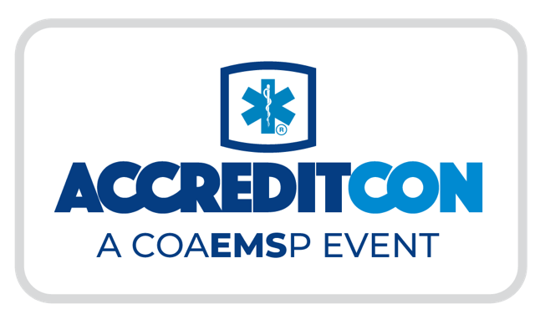
Date
Dear [SUPERVISOR’S NAME],
I am writing to request approval to attend ACCREDITCON, a CoAEMSP-hosted conference in New Orleans, Louisiana, from May 27–31.
ACCREDITCON is a comprehensive event focused on the CAAHEP accreditation process. The sessions, tools, and resources are directly aligned with my responsibilities and will strengthen my effectiveness in this role, ultimately benefiting our program.
The conference offers intensive, practice-oriented learning that builds on the accreditation workshops hosted by CoAEMSP. By attending, I will be able to participate in detailed how-to sessions, get answers to questions, and learn best practices from leaders and peers. As a result, ACCREDITCON will help our program to:
- Avoid costly, time-consuming accreditation errors.
- Conduct a more efficient and productive site visit.
- Incorporate ideas and tips from leaders, colleagues, and mentors.
- Work more efficiently and strategically.
- Identify concrete ways to improve our accreditation performance.
Based on information from the ACCREDITCON website (www.accreditcon.org), I am confident that my participation will have a direct, positive impact on our program’s quality and on my work as [OFFICIAL TITLE] for [NAME OF PROGRAM/ORGANIZATION]. After the conference, I will share key takeaways with our team and propose an action plan for implementation.
The estimated costs are:
- Airfare/Travel: [$ AMOUNT]
- Hotel: $/Night [$ AMOUNT]
- Meals: $/Day [$ AMOUNT]
- Event Registration: [$ AMOUNT]
- TOTAL: [$ AMOUNT]
Thank you for taking the time to review this request.
Best regards,
[YOUR NAME]

